Mt Lofty - SA
http://www.abc.net.au/news/2011-12-15/laser-binoculars-fire-smoke-sightings-cfs/3732648?section=sa

Laser binoculars to help bushfire fight
Updated December 16, 2011 08:24:10
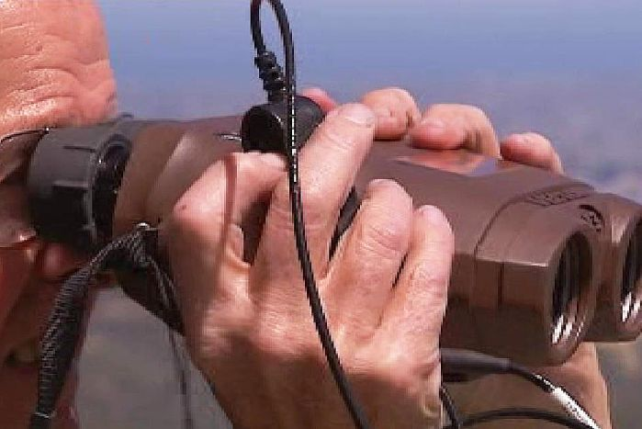Photo: Laser binoculars will help pinpoint fires from the Mt Lofty tower
For video; see link
http://www.abc.net.au/news/2011-12-15/high-tech-binoculars-donated-to-cfs/3734026
A defence firm has donated laser binoculars to the Country Fire Service (CFS) to help it pinpoint bushfire locations.
The binoculars will be used at the Mount Lofty tower in the Adelaide Hills to check smoke sightings.
CFS chief officer Greg Nettleton says the distance to a smoke plume can be measured and its exact location displayed on a map on a tablet computer.
"Once a fire gets going it allows us to get information and intelligence from the tower people, the volunteers in the tower so that they can also provide us information of where the fire was travelling to, roughly how fast it is travelling and then that information can be used in our warnings that go out to the community," he said.
"This will not replace any existing methods of fire detection or responses but will be a welcome addition to existing CFS resources."
BAE Systems said it was pleased to be able to support the CFS in its work.
Topics: emergency-planning, disasters-and-accidents, bushfire, computers-and-technology, sa, adelaide-5000
First posted December 15, 2011 11:01:55

